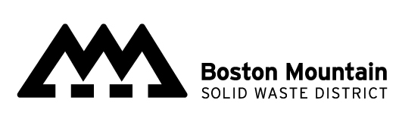
Recycling Grant
Request for Time Extension

Grant Number: Date: Grant Recipient:

Purpose The purpose of this form is to make a request for a time extension to begin or complete a Recycling Grant project.
General All items on the form must be completed and returned to the District. Incomplete forms will be returned to the grantee. Time extension requests should be submitted at least 30 days before the established deadline
Make no changes until both the RSWMD board chairman & District Director indicate approval by signing request
Project Phase (choose one)
Delay start of project | When will you start?
Extend time to complete | When will you complete?

Project Phase (choose one)
- Why has your project start/ complete date been delayed?
- How will you assure the new deadline will be met?

I certify that the information provided in and for this Request for Time Extension is accurate, and a time extension is warranted. I understand that if the required information has not been provided, this form will be returned and the request delayed.

These Changes are hereby approved and become a part of the grant agreement.

Applicants Authorized Representative Signature & Title |  | Date
BMSWD Director |  | Date
BMSWD Board Chair |  | Date

